SIMCOM GSM/VOICE MODEM

GENERAL DESCRIPTION

This GSM Modem can work with any GSM network operator SIM card just like a mobile phone with its own unique phone number. Advantage of using this modem will be that its RS232 port can be used to communicate and develop embedded applications. Applications like SMS Control, data transfer, remote control and logging can be developed easily using this.

The modem can either be connected to PC serial port directly or to any microcontroller through MAX232. It can be used to send/receive SMS and make/receive voice calls. It can also be used in GPRS mode to connect to internet and run many applications for data logging and control. In GPRS mode you can also connect to any remote FTP server and upload files for data logging.

PRODUCT DESCRIPTION

This GSM Modem can accept any GSM network act as SIM card and just like a mobile phone with its own unique phone number. Advantage of using this modem will be that you can use its RS232 port to communicate and develop embedded applications. The SIM800C is a complete Dual-band GSM/GPRS solution in a SMT module featuring an industry-standard interface, the SIM800CS is a quad-band GSM/GPRS module that works on frequencies GSM850MHz, delivers performance for voice, SMS, Data, and Fax in a small form factor and with low power consumption.

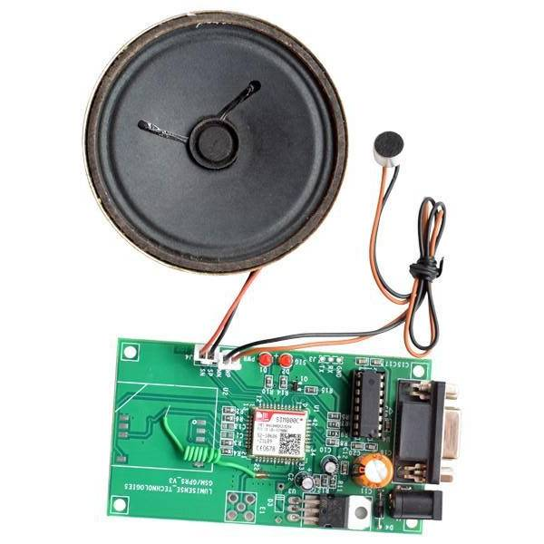

GSM voice modem

FEATURES

- High Quality Product

- RS232 interface @ RMC Connector for direct communication with computer or MCU kit

- Configurable baud rate

- SMA connector with GSM Antenna.

- SIM Card holder.

- Built in Network Status LED

- Inbuilt Powerful TCP/IP protocol stack for internet data transfer over GPRS.

- Audio interface Connector

- Normal operation temperature: -20 °C to +55 °C

- Input Voltage: 4.5V-12V DC

APPLICATIONS

- short message service(SMS)

- incoming/outgoing voice calls

- internet

- SMS based Remote Control and Alerts

- Security Applications

- Sensor Monitoring

- GPRS Mode Remote Data logging

